HTML image

**Table of content**

* What is HTML image?
* How to insert an Image in HTML document?
* Which are the important attributes used in HTML image tag?

**What is HTML image tag?**

HTML image tag is use for inserting an image into the webpage so that webpage will look too beautiful to see. In this case webpage does not allow to insert the image directly on the webpage. For inserting an image <img> tag is use with different attribute.

Image tag is user for inserting an image to the web page with the help of link or source of the particular image. Image tag does not have any closing tag.

**Syntax-**

<img src=”link” alt=”alternate text”>

Image tag is followed by two attribute one is src means source attribute which is use for specifying the path of the image and another is alt attribute which specify the alternate text which is written for an image.

**How to insert an Image in HTML document?**

For inserting an image into a webpage <img> tag required with src attribute for providing path or URL of the link.

HTML supports two type of file referencing to provide a particular link or path or any URL through which help to insert an image or to navigate through the link from one webpage to another.

* Relative file referencing-
* Absolute file referencing-

**Relative file referencing-**

Relative file referencing is applicable up to the current page or the path which is provided in the src tag is applicable only up to the local host.

**Example-**

<!DOCTYPE html>

<html>

  <head>

    <title>image tag</title>

  </head>

  <body>

    <img src="image 2.jpg"  />

  </body>

</html>

**Output-**

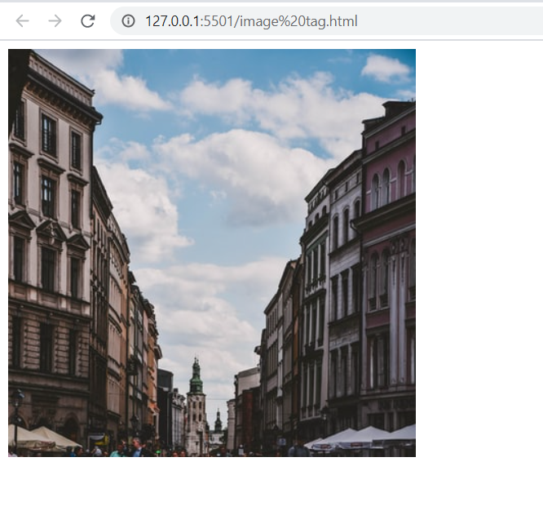

**Absolute file referencing-**

Absolute file referencing is use when any URL is provided as a link in the image tag. This file referencing is helps to navigate from one webpage to another or it will directly navigate on the same image which is provided in the URL.

**Example-**

<!DOCTYPE html>

<html lang="en">

  <head>

    <meta charset="UTF-8" />

    <meta name="viewport" content="width=device-width, initial-scale=1.0" />

    <title>Document</title>

  </head>

  <body>

    <img

      src="https://images.unsplash.com/photo-1517218313419-97711ffe5493?crop=entropy&cs=tinysrgb&fit=crop&fm=jpg&h=400&ixid=eyJhcHBfaWQiOjF9&ixlib=rb-1.2.1&q=80&w=400"

      width="300"

      height="300"

    />

  </body>

</html>

**Output-**



**Which are the important attributes used in HTML image tag?**

**SRC attribute-**

**What is SRC in HTML with example?**

If User want to import an image to the HTML document then it is required to mention the exact path of an image so that browser will easily recognize the image path and display the image to the webpage. This attribute will help to identify where exactly your Image file have been located in your compute.

**Syntax-** <img src=" path of an image " >

**Example-**

<!DOCTYPE html>

<html lang="en">

  <head>

    <meta charset="UTF-8" />

    <meta name="viewport" content="width=device-width, initial-scale=1.0" />

    <title>Document</title>

  </head>

  <body>

    <img src="image3.jfif"

    />

  </body>

</html>

**Output-**

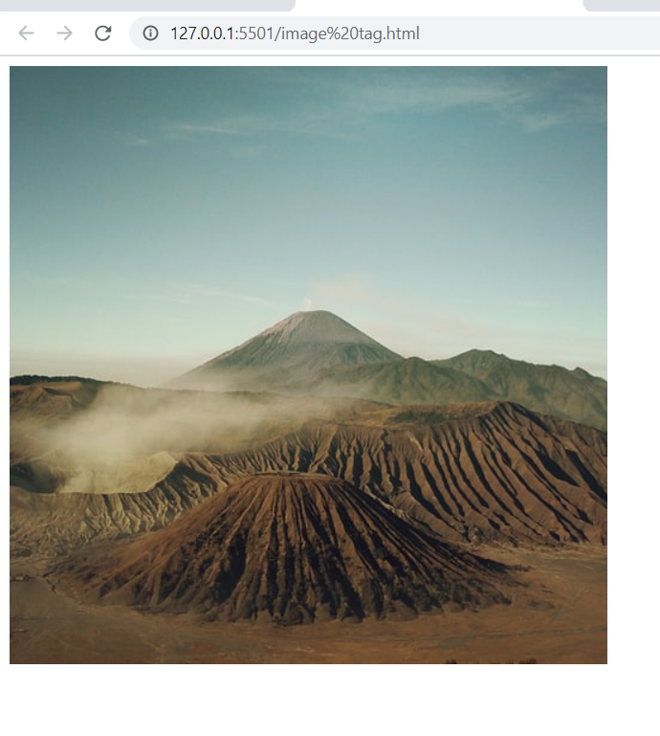

**ALT attribute-**

ALT attribute is use with the image tag. This attribute is use to provide an extra information about the image. If in case image will not upload because of any reason like wrong URL or wrong source or anything then for the user convenience alt attribute is provided along with image tag so that user can understand which type of image has been uploaded which is not visible in the webpage.

**Syntax**- <img alt =” text”>

The text which is written in the alt attribute must specify the information about image.

**Example-**

<!DOCTYPE html>

<html>

  <head>

    <title>image tag</title>

  </head>

  <body>

    <img src="black.jpg" alt="Black and white image of wallpaper"/>

  </body>

</html>

**Output-**

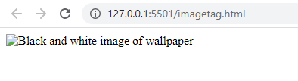

**Example Explain-**

In the above example, Image is unable to upload on the webpage in this case browser is unable to recognize the path of the image but alt attribute will help to identify which type of the image it is.

**Example-**

<!DOCTYPE html>

<html>

  <head>

    <title>image tag</title>

  </head>

  <body>

    <img src="image4.jfif" alt=" image of wallpaper"/>

  </body>

</html>

**Output-**



**Width and Height attribute-**

By using width and height attribute you can provide height and width to the HTML document. It is useful for browser to understand the image size when height and Width attribute is mention in the HTML document. If height and width attribute is mention in the code then it will be easier to understand the browser’s page that how much space is required for the particular image.

**Syntax-**

<img src="path" width="#" height="#" >

**Example-**

<!DOCTYPE html>

<html lang="en">

  <head>

    <meta charset="UTF-8" />

    <meta name="viewport" content="width=device-width, initial-scale=1.0" />

    <title>Document</title>

  </head>

  <body>

    <img

      src="https://images.unsplash.com/photo-1556575995-f36696a5cdd5?crop=entropy&cs=tinysrgb&fit=crop&fm=jpg&h=400&ixid=eyJhcHBfaWQiOjF9&ixlib=rb-1.2.1&q=80&w=400"

      width="300"

      height="300"

    />

  </body>

</html>

**Output-**

